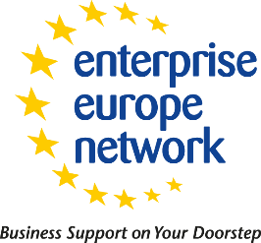
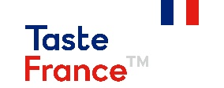
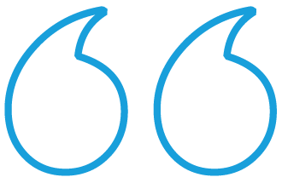

Meet many international buyers at a unique event in Paris or online.
BUSINESS MEETINGS
FOOD PARIS 2020

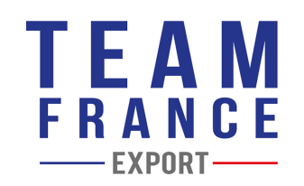
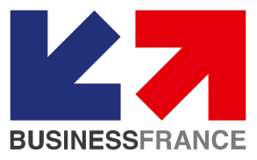
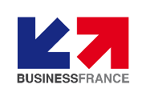
Business meetings are brought to you by:
Paris, France
19th-22nd October 2020
- WHO IS THE BUSINESS MEETINGS FOOD PARIS 2020 FOR?
- If you are an importer, distributor, wholesaler, retailer, etc. looking for new references of products, we can help you find and meet your future business partners.
- for food producers who are looking for new markets and new customers

We can help you meet your future business partners by arranging meetings, with a personalised programme that meets your specific needs.

- SECTEURS :
- Boissons
- Boulangrie, Viennoiserie, Pâtes
- Condiments, Epices
- Snacking

- Confiserie, confitures, desserts
- Préparations de fruits et legumes
- Produits laitiers
- Viandes

- HOW DOES IT WORK?
Benefit from targeted and pre-programmed business meetings with buyers identified by the teams of Business France and Enterprise Europe Network.

From July | STEP 1 | - Register on the Business Meetings Food Paris 2020 website  - Fill in your profile sheet  Deadline for registration: 1^{rst} of October 2020
July  -  October | STEP 2 | - Access the list of buyers on the Business Meetings Food Paris 2020 website  - You select the companies you are interested in and request the B2B appointments you are interested in.
July  – October | STEP 3 | - You will need to confirm the pre-agenda that will be sent to you.  - Invoicing of appointments accepted by buyers
19h-22nd October | MEETINGS | - You will receive your final schedule  - You will be able to meet your contacts in face to face or virtual in a dedicated area in Paris.***
Crédits photos : adodestock.com – gettyimages.fr
*** Meeting rooms equipped with video projectors will be at your disposal in the premises of Business France.

TARIFF :
• Supplier/Buyer meeting 100 €HT (excl. taxes)
• Supplier/supplier : free of charge

Testimony
Mr. Wolfgang Petzolt, Managing Director of IZ Frozen Imports in Germany:
“It is a time-saving solution and it really facilitates our sourcing”.
Video of Business Meetings Paris 2018

SERVICES :
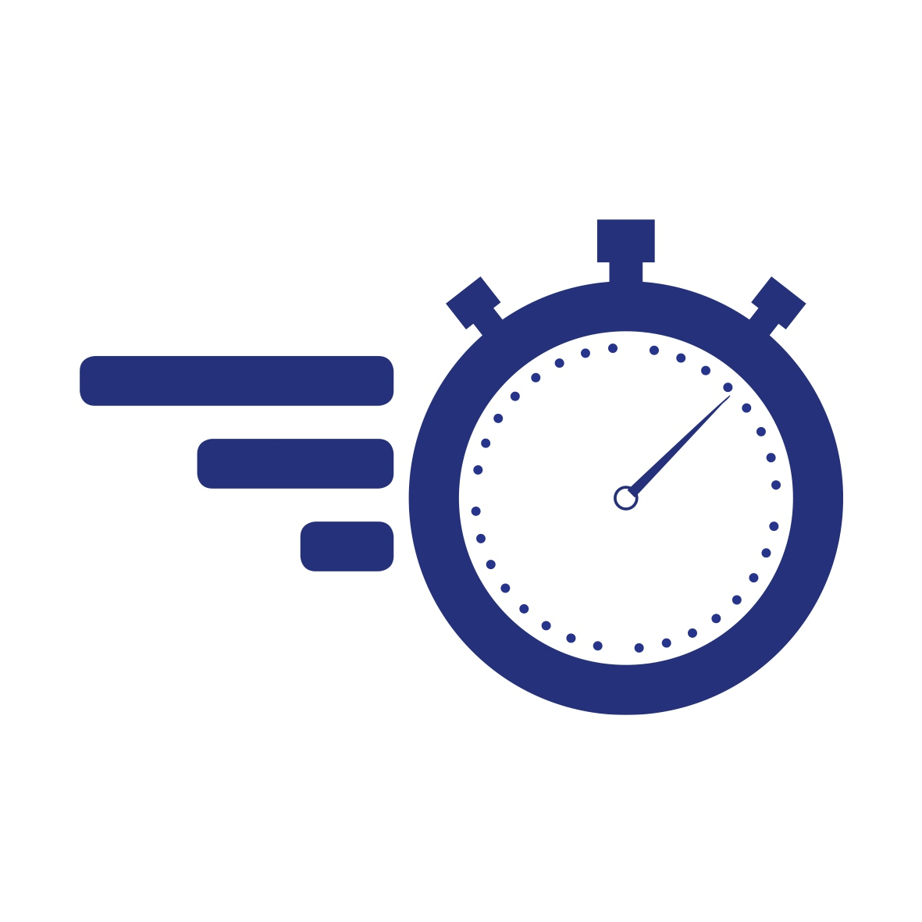 | - Pre-arranged and tailor-made meetings program
 | - A dedicated area for business meetings with free access to wifi, buffet and cloakrooms.
 | - Enterprise Europe Network and Business France teams will assist you before and during the show

- QUELQUES RECOMMANDATIONS POUR VOS RENDEZ-VOUS EN LIGNE :

- A virtual meeting link will be sent to you upon confirmation of your appointment.
- Log on 5 to 10 minutes in advance and bring your product samples.
- Be sure to check beforehand that your camera and your internet connection work properly.
- Begin your appointment with the expert from the country concerned. You will have 45min of connection time.
- Don't forget to ask for contact details and ask any questions you may have.
- Send your product samples when requested.

CONTACTS
 | Anne-Colette ALAIN  EEN Normandie  Conseiller International TFE Normandie / Agrotech  anne-colette.alain@normandie.cci.fr  T : +33.(0)6. 31.37.77.02 | Géraldine LECARPENTIER  EEN Normandie  Conseiller International TFE Normandie / Agrotech  geraldine.lecarpentier@normandie.cci.fr  T : +33.(0)7.89.44.97.54

