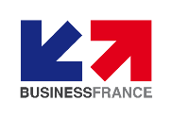
Paris, France
19th-22nd October 2020
Meet a selection of companies during meetings in Paris or online meetings.
BUSINESS MEETINGS
VIP BUYERS PROGRAM

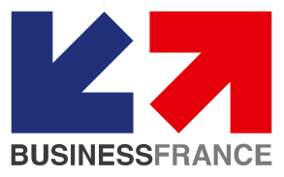
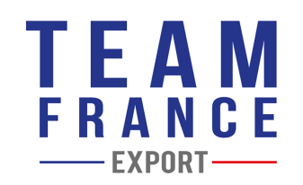
Business meetings are brought to you by:

- HOW CAN WE HELP?

If you are an importer, distributor, wholesaler, retailer, etc. looking for new references of products, we can help you find and meet your future business partners.

Our solution is aimed at international buyers who are seeking to source new products and expand their business network. We offer a personalised program of Business Meetings tailored to your specific needs.

Business Meetings Food Paris:

Business France and EEN can find suppliers of the following product categories, matching your needs:

- Beverages
- Bread & Bakery, Pasta
- Condiments, Spices
- Cookies, Snack & Candy, jams, fruit desserts
- Fruit and vegetable preparations
- Dairy products
- Meat and poultry products

Testimony
Mr. Wolfgang Petzolt, Managing Director of IZ Frozen Imports in Germany:
“It is a time-saving solution and it really facilitates our sourcing”.

Watch the 2018 edition video: [ HERE ]
YOUR ENGAGEMENTS:
- View and select companies from our dedicated website.
- Honor the arrangements made regarding your business meetings, planned visits and Business France/ EEN ‘s VIP cocktail.
- Enjoy your tailor-made meetings program in Paris.

- HOW DOES IT WORK?

From July | STEP 1 | - You identify product categories & indicate your selection criteria for food products and register on the Business Meeting Food Paris website.
July  -  October | STEP 2 | - Our Business Meeting website gives you free access to the suppliers’ catalog.  - You select companies and request one-to-one meetings during the event at convenient time slots.
July  – October | STEP 3 | - We will inform suppliers then organize and send you your personalized meeting program.
19th-22nd October | OPTION 1 :  Meetings  In Paris | - We will assign you a meeting room in dedicated meeting room.  - Possible visit of Rungis wholesale market & the luxury retailers.
 | OPTION 2 :  Online  meetings | - We will assign you a virtual meeting room and help you to connect with the supplier.  - Choose whether the supplier need to send samples before or after the meeting.
SERVICES INCLUDED IN THE VIP BUYER’S PROGRAM:
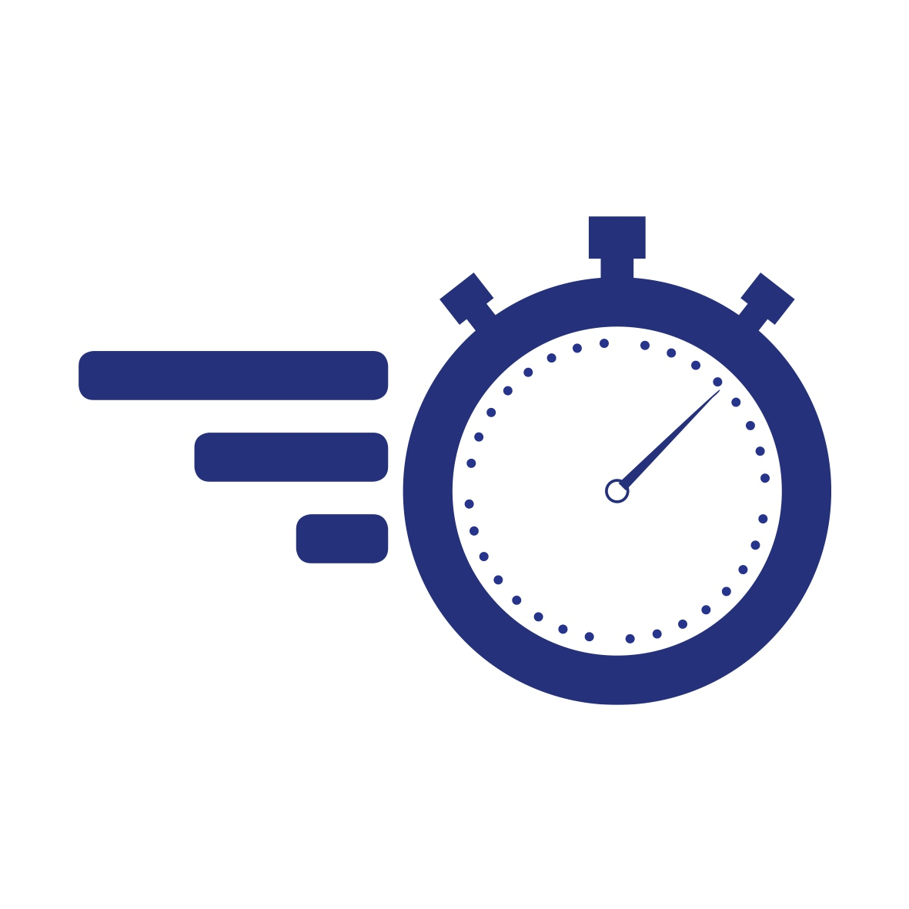 | - Pre-arranged and tailor-made meetings program.  - Assistance can be provided for transports, registration, and other logistics concerns if you are able to travel.
 | - A privatised meetings lounge or virtual meeting room if you choose option 2.
 | - Assistance from your Business France and EEN local expert before and during meetings.

NAME  Position  Phone :  Email : | Hugo LE BAIL  BtoB Event manager - FRANCE  Phone : +33 (0)1 40 73 31 21  hugo.lebail@businessfrance.fr | Estelle BURGIO  Project manager - FRANCE  Phone : +33 1 40 73 31 21  Estelle.burgio@businessfrance.fr

CONTACTS

